**BANK LOAN REPORT**

**TERMINOLOGIES USED IN DATA**

**Fields Used in Data**

**Loan ID:**

**Purpose: Loan ID is a unique identifier assigned to each loan application or loan account. It serves as a primary key for tracking and managing individual loans.**

**Use for Banks: Banks use Loan IDs to efficiently manage and track loans throughout their lifecycle. It aids in organizing loan records, monitoring repayments, and addressing customer inquiries.**

**Address State:**

**Purpose: Address State indicates the borrower's location. It helps in assessing regional risk factors, compliance with state regulations, and estimating default probabilities.**

**Use for Banks: Banks use this information to identify regional trends in loan demand, adjust marketing strategies, and manage risk portfolios based on geographic regions.**

**Employee Length:**

**Purpose: Employee Length provides insights into the borrower's employment stability. Longer employment durations may indicate greater job security.**

**Use for Banks: Banks consider employment length when assessing a borrower's ability to repay. Stable employment often translates to a lower default risk.**

**Employee Title:**

**Purpose: Employee Title specifies the borrower's occupation or job title. It helps lenders understand the source of the borrower's income.**

**Use for Banks: Banks use this field to verify income sources, assess the borrower's financial capacity, and tailor loan offers to different professions.**

**Grade:**

**Purpose: Grade represents a risk classification assigned to the loan based on creditworthiness. Higher grades signify lower risk.**

**Use for Banks: Banks use the grade to price loans and manage risk. Higher-grade loans typically receive lower interest rates and are more attractive to investors.**

**Sub Grade:**

**Purpose: Sub Grade refines the risk assessment within a grade, providing additional risk differentiation.**

**Use for Banks: Sub Grades offer a finer level of risk assessment, helping banks tailor interest rates and lending terms to match borrower risk profiles.**

**Home Ownership:**

**Purpose: Home Ownership indicates the borrower's housing status. It offers insights into financial stability.**

**Use for Banks: Banks use this field to assess collateral availability and borrower stability. Homeowners may have lower default rates.**

**Issue Date:**

**Purpose: Issue Date marks the loan's origination date. It's crucial for loan tracking and maturity calculations.**

**Use for Banks: Banks use Issue Dates to track loan aging, calculate interest accruals, and manage loan portfolios.**

**Last Credit Pull Date:**

**Purpose: Last Credit Pull Date records when the borrower's credit report was last accessed. It helps monitor creditworthiness.**

**Use for Banks: Banks use this date to track credit history updates, assess credit risk, and make informed lending decisions.**

**Last Payment Date:**

**Purpose: Last Payment Date marks the most recent loan payment received. It tracks the borrower's payment history.**

**Use for Banks: Banks use this date to assess payment behavior, calculate delinquency, and project future payments.**

**Loan Status:**

**Purpose: Loan Status indicates the current state of the loan (e.g., fully paid, current, default). It tracks loan performance.**

**Use for Banks: Banks use Loan Status to monitor loan health, categorize loans for risk analysis, and determine provisioning requirements.**

**Next Payment Date:**

**Purpose: Next Payment Date estimates the date of the next loan payment. It assists in cash flow forecasting.**

**Use for Banks: Banks use this date for liquidity planning and to project revenue from loan portfolios.**

**Purpose:**

**Purpose: Purpose specifies the reason for the loan (e.g., debt consolidation, education). It helps understand borrower intentions.**

**Use for Banks: Banks use this field to segment and customize loan offerings, aligning loan terms with borrower needs.**

**Term:**

**Purpose: Term defines the duration of the loan in months. It sets the repayment period.**

**Use for Banks: Banks use the term to structure loan agreements, calculate interest payments, and manage loan maturities.**

**Verification Status:**

**Purpose: Verification Status indicates whether the borrower's financial information has been verified. It assesses data accuracy.**

**Use for Banks: Banks use this field to gauge data reliability, verify income, and evaluate loan application credibility.**

**Annual Income:**

**Purpose: Annual Income reflects the borrower's total yearly earnings. It assesses repayment capacity.**

**Use for Banks: Banks use this income figure to determine loan eligibility, calculate debt-to-income ratios, and evaluate creditworthiness.**

**DTI (Debt-to-Income Ratio):**

**Purpose: DTI measures the borrower's debt burden relative to income. It gauges the borrower's capacity to take on additional debt.**

**Use for Banks: Banks use DTI to assess a borrower's ability to handle loan payments and make responsible lending decisions.**

**Instalment:**

**Purpose: Instalment is the fixed monthly payment amount for loan repayment, including principal and interest.**

**Use for Banks: Banks use this field to structure loan terms, calculate amortization schedules, and assess payment affordability.**

**Interest Rate:**

**Purpose: Interest Rate represents the annual cost of borrowing expressed as a percentage. It determines the loan's cost.**

**Use for Banks: Banks use interest rates to price loans, manage profit margins, and attract investors.**

**Loan Amount:**

**Purpose: Loan Amount is the total borrowed sum. It defines the principal amount.**

**Use for Banks: Banks use Loan Amount to determine loan size**

**BANK LOAN REPORT QUERY DOCUMENT**

1. **BANK LOAN REPORT | SUMMARY**

SELECT * FROM bank_loan_data

**Total Loan Applications**

SELECT COUNT(id) AS Total_Applications FROM bank_loan_data

**MTD(Mionth-to-Date) Loan Applications**

SELECT COUNT(id) AS Total_Applications FROM bank_loan_data

WHERE MONTH(issue_date) = 12

**PMTD(Previous- month-to-date) Loan Applications**

SELECT COUNT(id) AS Total_Applications FROM bank_loan_data

WHERE MONTH(issue_date) = 11



**Total Funded Amount**

SELECT SUM(loan_amount) AS Total_Funded_Amount FROM bank_loan_data



**MTD Total Funded Amount**

SELECT SUM(loan_amount) AS Total_Funded_Amount FROM bank_loan_data

WHERE MONTH(issue_date) = 12



**PMTD Total Funded Amount**

SELECT SUM(loan_amount) AS Total_Funded_Amount FROM bank_loan_data

WHERE MONTH(issue_date) = 11



**Total Amount Received**

SELECT SUM(total_payment) AS Total_Amount_Collected FROM bank_loan_data



**MTD Total Amount Received**

SELECT SUM(total_payment) AS Total_Amount_Collected FROM bank_loan_data

WHERE MONTH(issue_date) = 12

**PMTD Total Amount Received**

SELECT SUM(total_payment) AS Total_Amount_Collected FROM bank_loan_data

WHERE MONTH(issue_date) = 11



**Average Interest Rate**

SELECT AVG(int_rate)*100 AS Avg_Int_Rate FROM bank_loan_data



**MTD Average Interest**

SELECT AVG(int_rate)*100 AS MTD_Int_Rate FROM bank_loan_dataWHERE MONTH(issue_date) = 12



**PMTD Average Interest**

SELECT AVG(int_rate)*100 AS PMTD_Int_Rate FROM bank_loan_data

WHERE MONTH(issue_date) = 11

**Avg DTI**

SELECT AVG(dti)*100 AS Avg_DTI FROM bank_loan_data

**MTD Avg DTI**

SELECT AVG(dti)*100 AS MTD_Avg_DTI FROM bank_loan_data

WHERE MONTH(issue_date) = 12

**PMTD Avg DTI**

SELECT AVG(dti)*100 AS PMTD_Avg_DTI FROM bank_loan_data

WHERE MONTH(issue_date) = 11

**GOOD LOAN ISSUED**

**Good Loan Percentage**

SELECT (COUNT(CASE WHEN loan_status ='Fully Paid' OR loan_status ='Current' THEN id END) * 100.0)/

COUNT(id) AS Good_Loan_Percentage FROM bank_loan_data



**Good Loan Applications**

SELECT COUNT(id) AS Good_Loan_Applications FROM bank_loan_data

WHERE loan_status ='Fully Paid' OR loan_status ='Current'

**Good Loan Funded Amount**

SELECT SUM(loan_amount) AS Good_Loan_Funded_amount FROM bank_loan_data

WHERE loan_status = 'Fully Paid' OR loan_status = 'Current'

**Good Loan Amount Received**

SELECT SUM(total_payment) AS Good_Loan_Amount_Received FROM bank_loan_data

WHERE loan_status = 'Fully Paid' OR loan_status = 'Current'

**BAD LOAN ISSUED**

**Bad Loan Percentage**

SELECT (COUNT(CASE WHEN loan_status = 'Charged Off' THEN id END)*100.0)

/COUNT(id) AS Bad_Loan_Percentage

FROM bank_loan_data

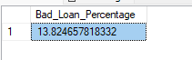

**Bad Loan Applications**

SELECT COUNT(id) AS Bad_Loan_Applications FROM bank_loan_data

WHERE loan_status ='Charged Off'

**Bad Loan Funded Amount**

SELECT SUM(loan_amount) AS Bad_Loan_Funded_Amount FROM bank_loan_data

WHERE loan_status ='Charged Off'

**Bad Loan Amount Received**

SELECT SUM(total_payment) AS Bad_Loan_Amount_Received FROM bank_loan_data

WHERE loan_status ='Charged Off'

**LOAN STATUS**

SELECT

loan_status,

COUNT(id) AS LoanCount,

SUM(total_payment) AS Total_Amount_Received,

SUM(loan_amount) AS Total_Funded_Amount,

AVG(int_rate * 100) AS Interest_Rate,

AVG(dti * 100) AS DTI

FROM bank_loan_data

GROUP BY

loan_status

SELECT

loan_status,

SUM(total_payment) AS MTD_Total_Amount_Received,

SUM(loan_amount) AS MTD_Total_Funded_Amount

FROM bank_loan_data

WHERE MONTH(issue_date) = 12

GROUP BY

loan_status

1. **BANK LOAN REPORT| OVERVIEW**

**MONTH**

**SELECT**

**MONTH(issue_date) AS Month_Murder,**

**DATENAME(MONTH, issue_date) AS Month_Name,**

**COUNT(id) AS Total_Funded_Amount,**

**SUM(loan_amount) AS Total_Funded_Amount,**

**SUM(total_payment) AS Total_Amount_Received**

**FROM bank_loan_data**

**GROUP BY MONTH(issue_date), DATENAME(MONTH, issue_date)**

**ORDER BY MONTH(issue_date)**

**STATE**

**SELECT**

**address_state AS State,**

**COUNT(id) AS Total_Loan_Applications,**

**SUM(loan_amount) AS Total_Funded_Amount,**

**SUM(total_payment) AS Total_Amount_Received**

**FROM bank_loan_data**

**GROUP BY address_state**

**ORDER BY address_state**

**TERM**

**SELECT**

**term AS Term,**

**COUNT(id) AS Total_Loan_Applications,**

**SUM(loan_amount) AS Total_Funded_Amount,**

**SUM(total_payment) AS Total_Amount_Received**

**FROM bank_loan_data**

**GROUP BY term**

**ORDER BY term**

**EMPLOYEE LENGTH**

**SELECT**

**emp_length AS Employee_Length,**

**COUNT(id) AS Total_Loan_Applications,**

**SUM(loan_amount) AS Total_Funded_Amount,**

**SUM(total_payment) AS Total_Amount_Received**

**FROM bank_loan_data**

**GROUP BY emp_length**

**ORDER BY emp_length**

**PURPOSE**

**SELECT**

**purpose AS PURPOSE,**

**COUNT(id) AS Total_Loan_Applications,**

**SUM(loan_amount) AS Total_Funded_Amount,**

**SUM(total_payment) AS Total_Amount_Received**

**FROM bank_loan_data**

**GROUP BY purpose**

**ORDER BY purpose**

**HOME OWNERSHIP**

**SELECT**

**home_ownership AS Home_Ownership,**

**COUNT(id) AS Total_Loan_Applications,**

**SUM(loan_amount) AS Total_Funded_Amount,**

**SUM(total_payment) AS Total_Amount_Received**

**FROM bank_loan_data**

**GROUP BY home_ownership**

**ORDER BY home_ownership**

**Find the *See the results when we hit Grade A in the filters for dashboards.***

**SELECT**

**purpose AS PURPOSE,**

**COUNT(id) AS Total_Loan_Applications,**

**SUM(loan_amount) AS Total_Funded_Amount,**

**SUM(total_payment) AS Total_Amount_Received**

**FROM bank_loan_data**

**WHERE grade ='A'**

**GROUP BY purpose**

**ORDER BY purpose**

**Summary**

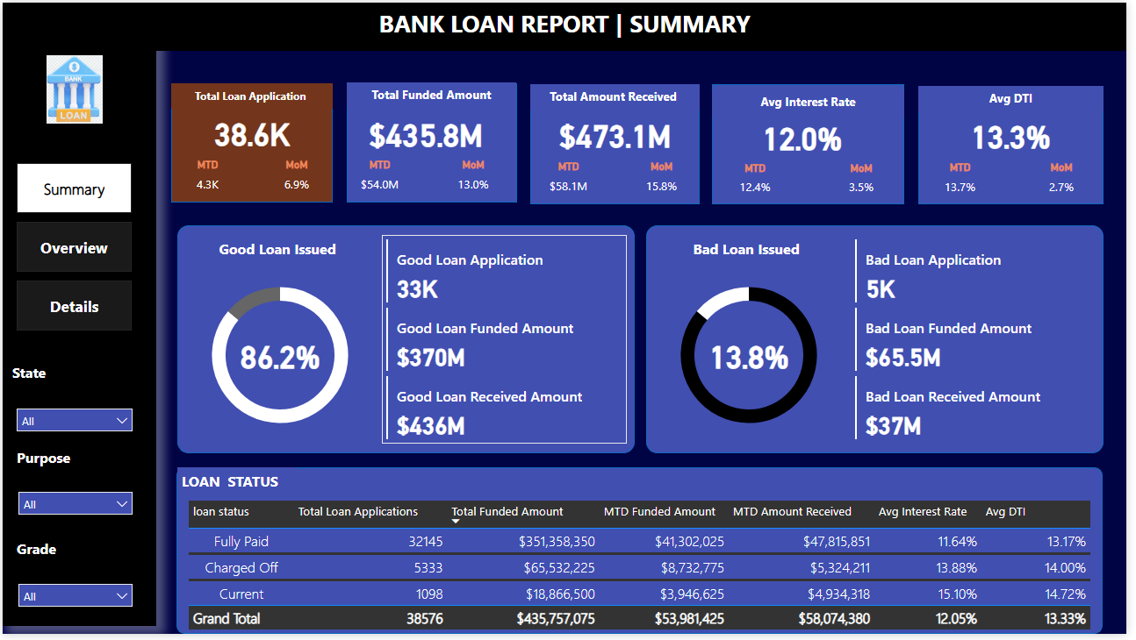

**Overview**

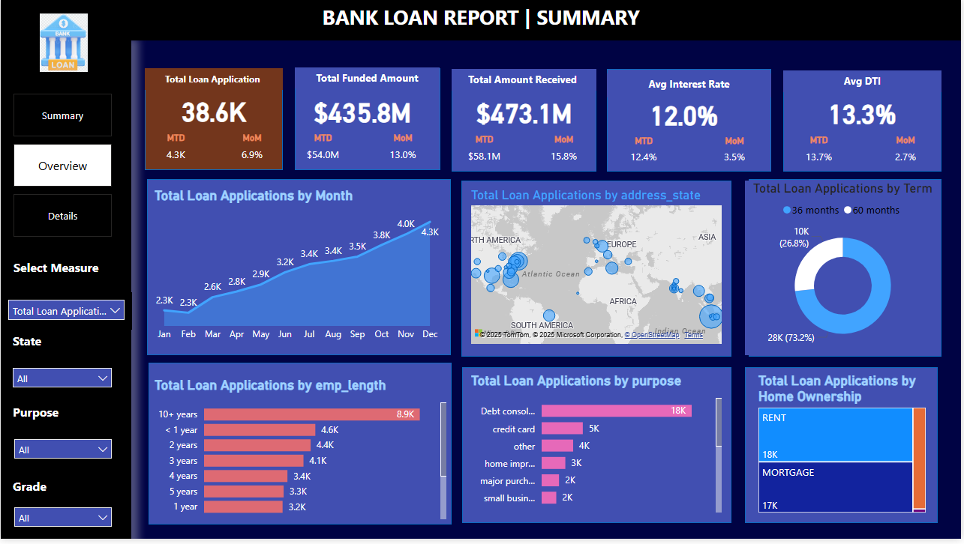

**Details**

